Feature from the box | What does this represent? | How does this link to your knowledge of Watkin in Grimsby and Cleethorpes?
Grimsby Docks etching
Prince Albert Statue
Cleethorpes Pier scene
Edward Watkin’s motto and initials
Manchester, Sheffield and Lincolnshire Railway Badges
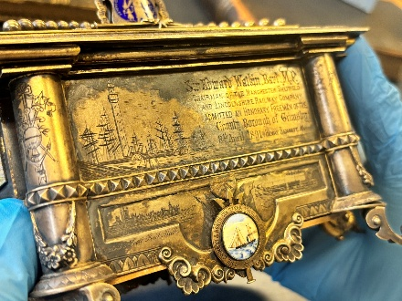
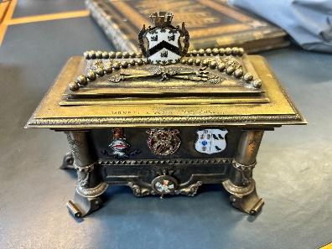
Edward Watkin Commemorative Box: Activity
Use the symbols and imagery from Watkin’s commemorative box to explain their meaning and how this links to your knowledge of Watkin’s working Grimsby and Cleethorpes.

