WATKIN RELATED PLAQUES

Where | Image | Reason
Central Station  Manchester  M2 3GX | 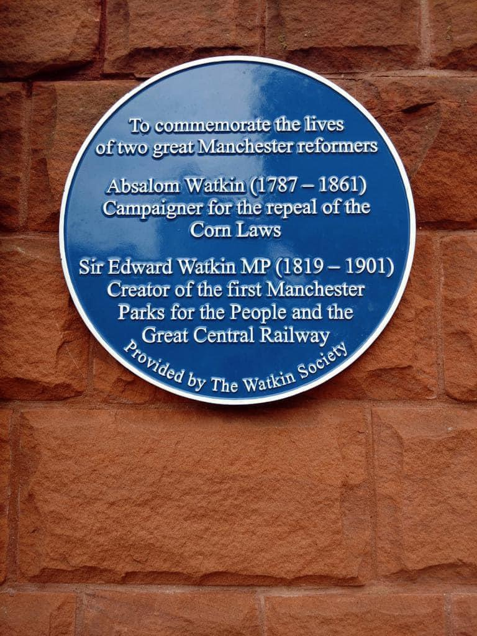 | Provided by The Watkin Society  To commemorate the lives of Absalom & Edward Watkin.
Philips Park  Manchester  M11 4DQ | 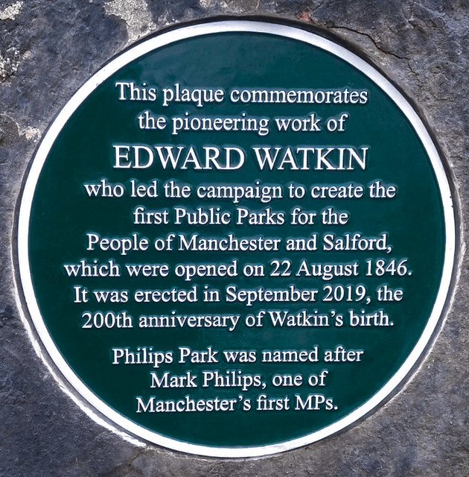 | To commemorate Edward Watkin who led the campaign to create the first public parks for the people of Manchester and Salford.
Loughborough Station  LE11 1EX | 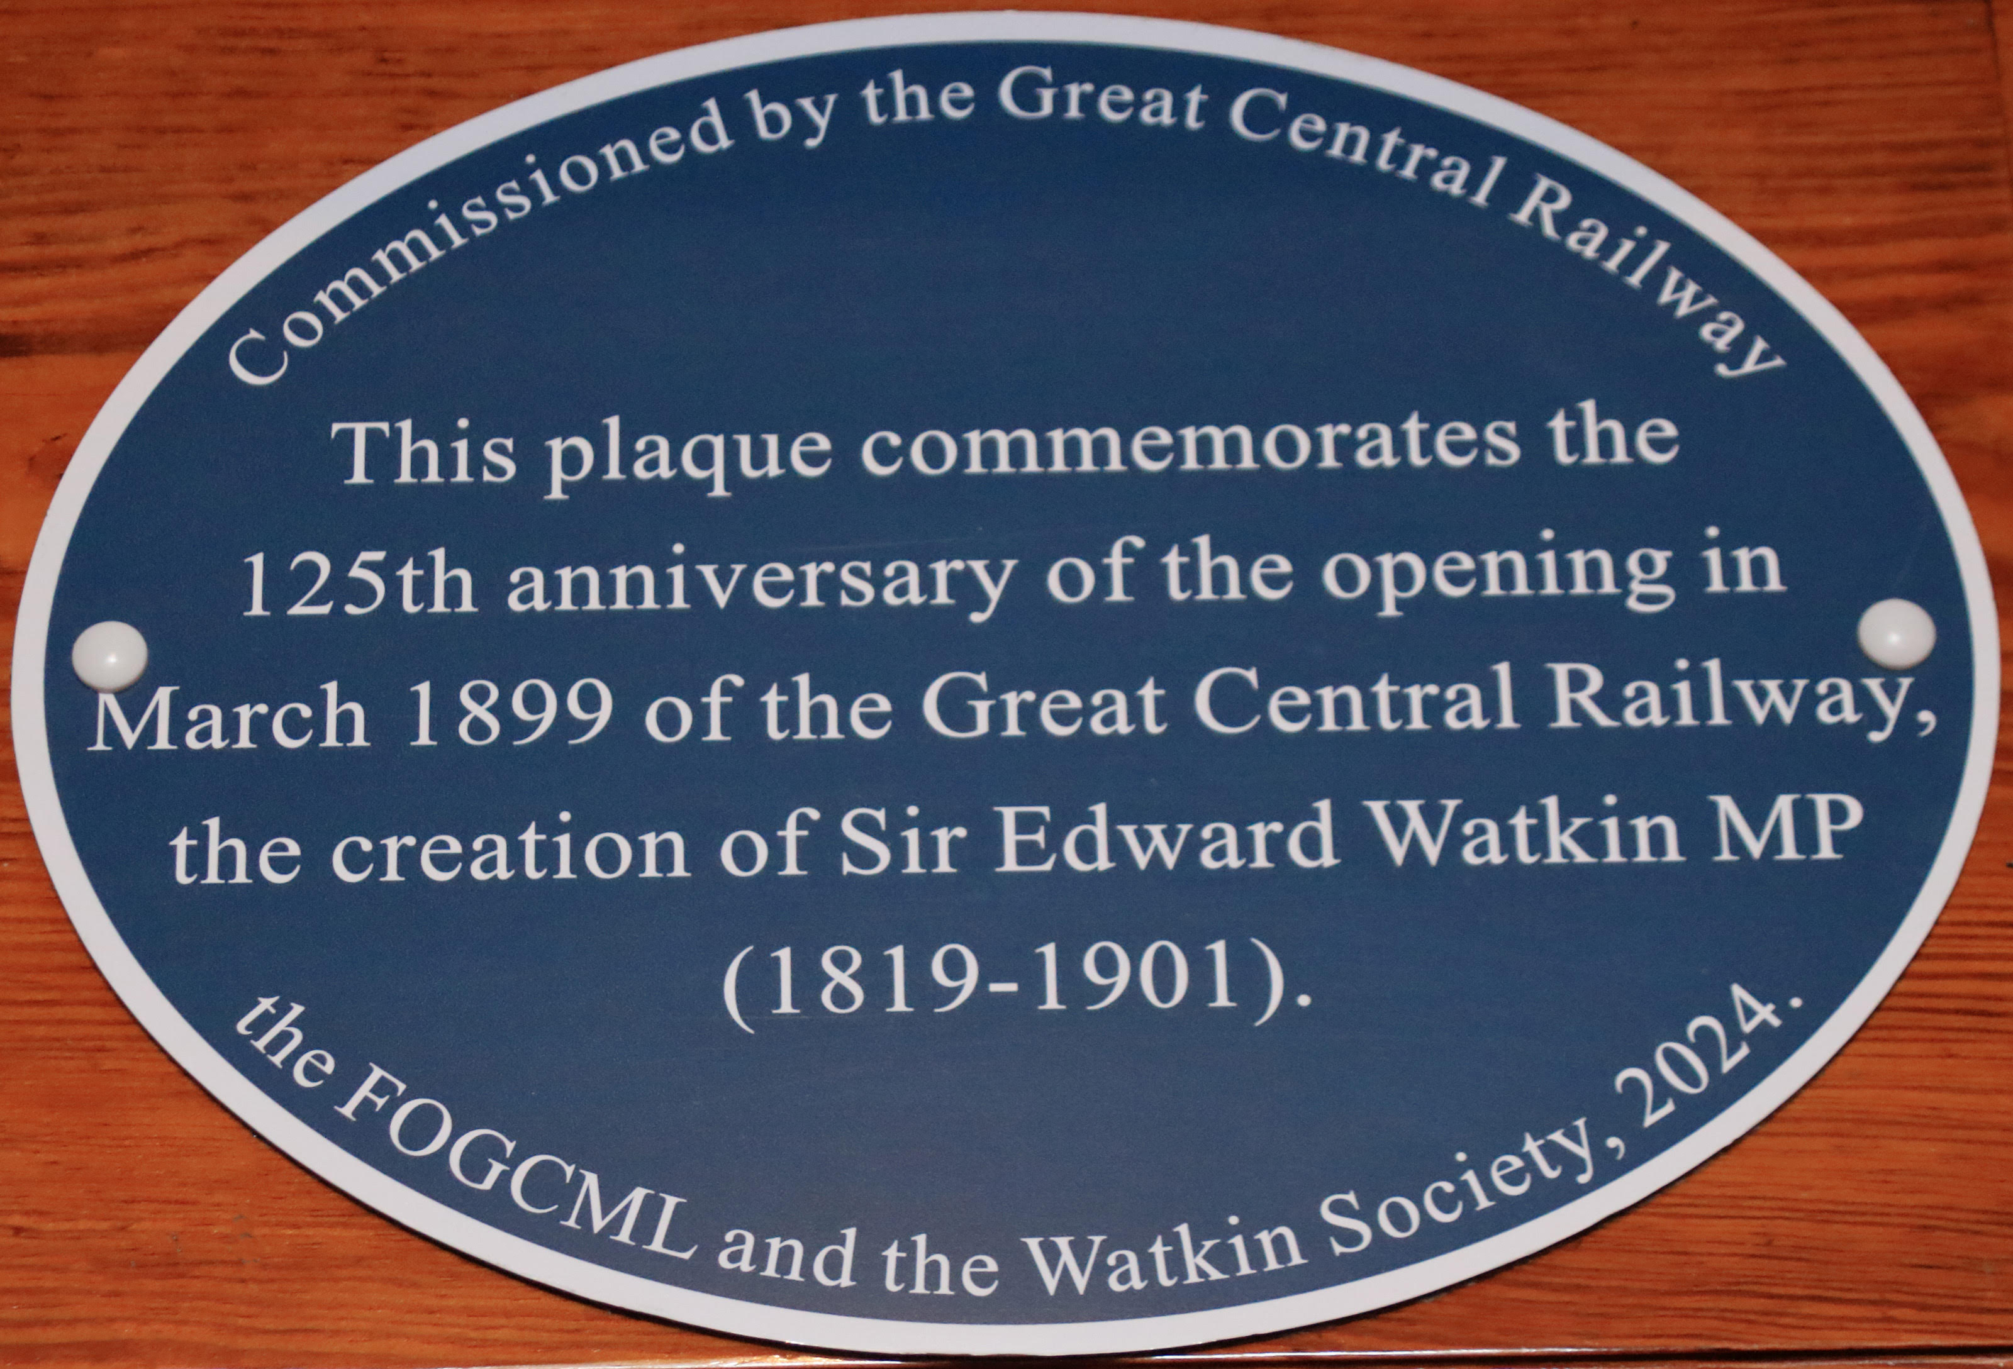 | Commissioned by the Great Central Railway, FOGCML & the Watkin Society  125th anniversary of the opening of the Great Central Railway, created by Sir Edward Watkin.
Marylebone Station  NW1 6JJ | 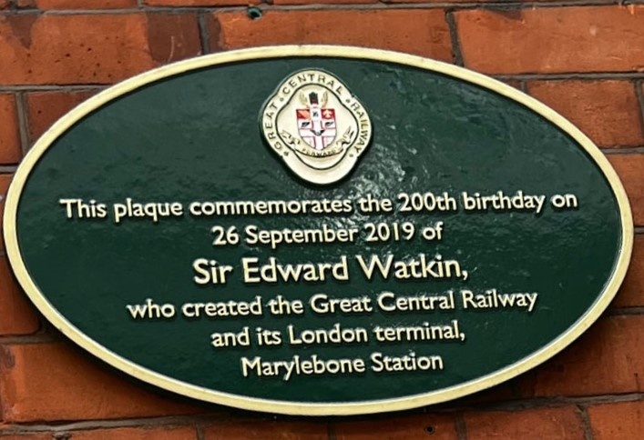 | o commemorate the 200th Birthday on 26 September 2019 of Sir Edward Watkin, creator of the Great Central Railway and Marylebone Station
Cleethorpes Station  DN35 8AX | 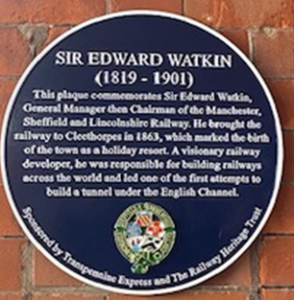 | Sponsored by TransPennine Express and The Railway Heritage Trust in 2024  In recognition of Sir Edward Watkin’s and MSLR’s contribution to the development of Cleethorpes as a holiday resort.
Cleethorpes Original Station DN35 8AX | 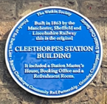 | Sponsored by: The Watkin Society, Grimsby Cleethorpes &District Civic Society, Barton Cleethorpes Community Rail Partnership and Friends of Barton Line  To commemorate the original 1863 station building in 2025.
Yarborough Hotel  (Wetherspoons)  Bethlehem Street  DN31 1JN | 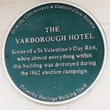 | GCDCS & Grimsby Heritage Walking Trail  Built in 1851 for the second Earl of Yarborough and The Royal Dock Company and enlarged in 1891  Not to be missed today is the restored decorative Victorian ceiling in the ladies’ loo!  Negotiations are taking place with Wetherspoons regarding its replacement.
Grimsby Fishing Heritage Centre  DN31 1HG | 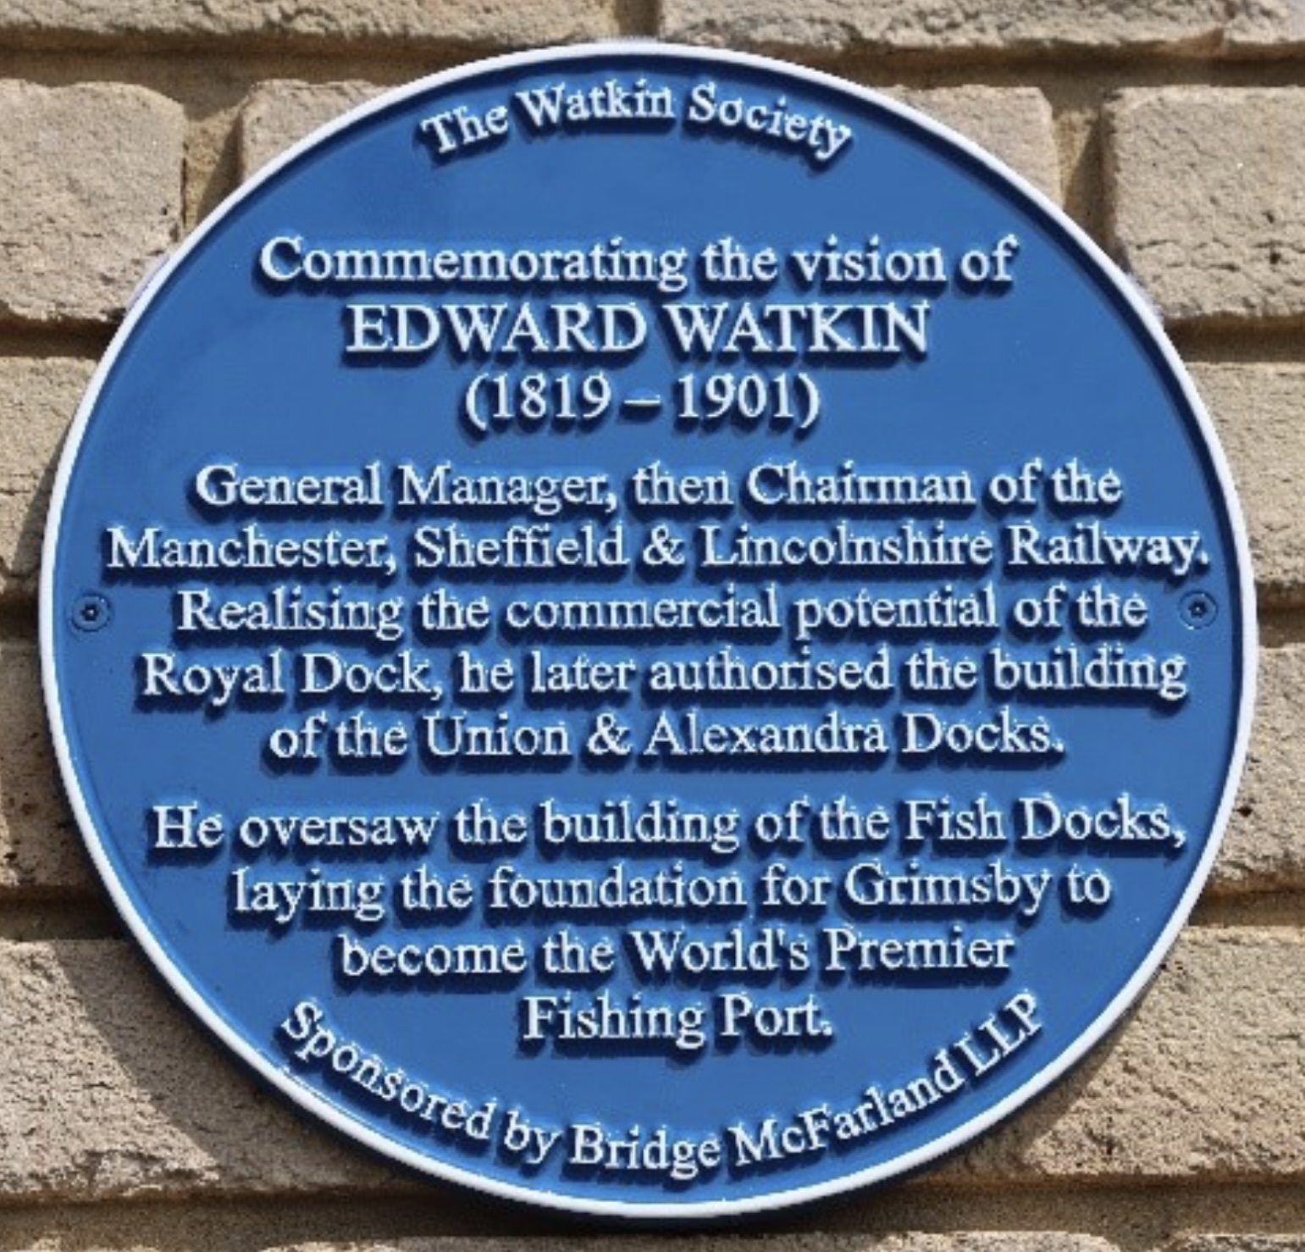 | Sponsored by Bridge McFarland, Grimsby  To Commemorate Edward Watkin and his contribution to the development of Grimsby into the World’s Premier Fishing Port.

